**Aim:** **Develop a form which search and display student list in gridview.**

**Code: Form1.cs**

using System;

using System.Collections.Generic;

using System.ComponentModel;

using System.Data;

using System.Drawing;

using System.Linq;

using System.Text;

using System.Threading.Tasks;

using System.Windows.Forms;

using System.Data.SqlClient;

namespace Practical_11

{

public partial class Form1 : Form

{

public Form1()

{

InitializeComponent();

}

private void button1_Click(object sender, EventArgs e)

{

SqlConnection cn = new SqlConnection(@"Data Source=(LocalDB)\MSSQLLocalDB;AttachDbFilename=C:\Users\Vandan\Documents\test1.mdf;Integrated Security=True;Connect Timeout=30");

string search_data = @"Select * from Student_information where EnrollmentNumber= '" + textBox1.Text + "'";

//SqlCommand s = new SqlCommand(search_data, cn);

SqlDataAdapter sda = new SqlDataAdapter(search_data,cn);

DataTable tb = new DataTable();

sda.Fill(tb);

dataGridView1.DataSource = tb;

}

}

}

**Form1.cs[Design]**

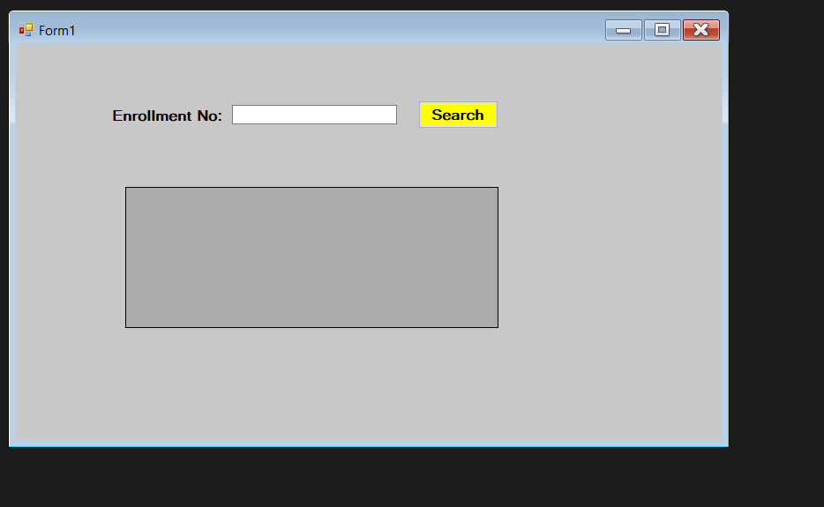

**Output:**

